***Project Design Phase-II***

***Data Flow Diagram &User Stories***

|  |  |
| --- | --- |
| Date | **5/11/2022** |
| Team ID | **PNT2022TMID43723** |
| Project Name | **Project – Natural Disasters Intensity Analysis and Classification Using Artificial Intelligence** |
| Maximum Marks | 4 Marks |

***Data Flow Diagrams:***

A Data Flow Diagram (DFD) is a traditional visual representation of the information flows within a system. A neat and clear DFD can depict the right amount of the system requirement graphically. It shows how data enters and leaves the system, what changes the information, and where data is stored.

***Data Flow Diagram for “Natural Disasters Intensity Analysis and Classification using Artificial Intelligence”:***

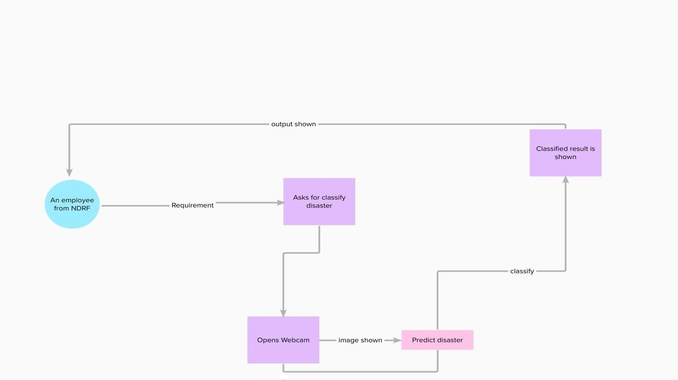

***User Stories***

Here the list all the user stories for the project “Natural Disaster Intensity Analysis and Classification Using Artificial Intelligence.”

|  |  |  |  |  |  |  |
| --- | --- | --- | --- | --- | --- | --- |
| **User Type** | **Functional**  **Requirement (Epic)** | **User**  **Story**  **Number** | **User Story / Task** | **Acceptance criteria** | **Priority** | **Release** |
| Customer | Registration | USN-1 | As a user, registration should be done | Proper email id and password is accepted | High | Sprint-1 |
| Customer | Area to be monitored | USN-2 | As user ,I can particularly select the area to be continuously checked and analyzed | The areas should be checked and selected without lapse. | Medium | Sprint-1 |
| Customer | Safety | USN-3 | As a user,I should monitor the device is in the secured place which should cover wide area | Safety measures should be done to prevent disaster | High | Sprint-2 |
| Customer | Examination of Natural anamoly | USN-4 | As a user,I should analyse the depth of the occurrence of the phenomena | I should monitor the factors which causes disaster | High | Sprint-1 |
| Customer | Battery Backup | USN-5 | As a user,I want to check the battery to prevent from power loss | Aware to always keep battery backup  .Sometimes it may help in any crucial situations. | Low | Sprint-3 |
| Customer | Algorithm to be used | USN-6 | As a user,I should be very conscious in selecting required algorithm | Algorithm provides a correct understanding about the model designed. | Medium | Sprint-4 |
| Customer(Web  user) | Internet  Connectivity | USN-7 | As a user,I should monitor the internet connection periodically | Strong internet connection is required in emergency situations. | High | Sprint-2 |
| Customer(web User) | Social media | USN-8 | As a user ,I will be active in social media sites to know more updates about specific diasaster | Active in social media sites to know  updates | Medium | Sprint-4 |
| Customer | Prediction and analysis of data | USN-9 | As a user,I can ale to predict and visualize data | Using algorithms and some visualization techniques to predict disaster. | High | Sprint-3 |
| Customer | Generating the possible outcome | USN-10 | As a user,generating possible output for the disaster occurrence | Several disasters can be  captured and output is  shown | High | Sprint-4 |